The pi vending machine works by using raspberry pi as its main controller allowing users to select products via a keypad and dispense items after a point transaction is confirmed. In this picture Raspberry pi which is the controller.

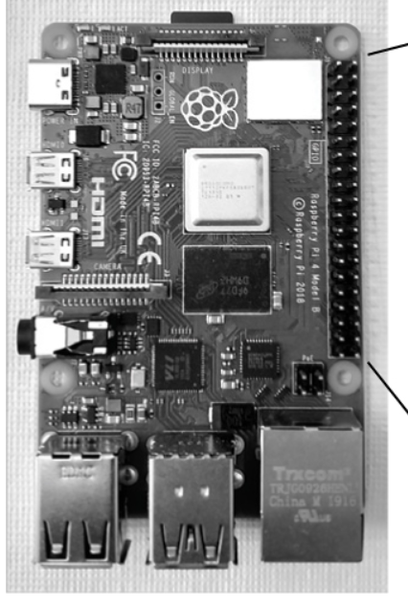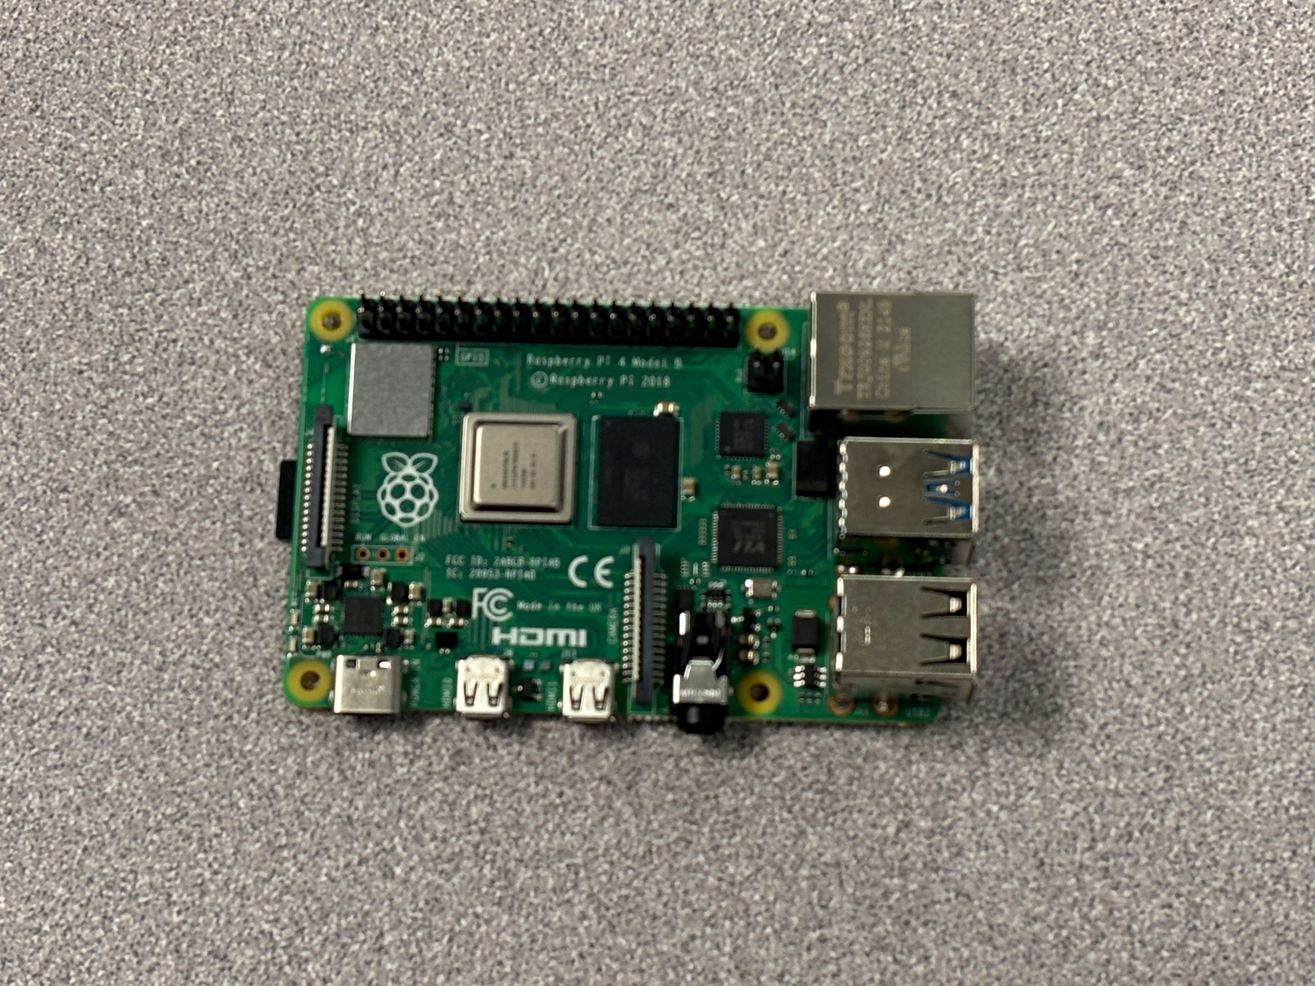

In the second phase we were supposed to hook the raspberry pi up to a breadboard which is a circuit. It had an LED light to see if the vending machine was working properly.

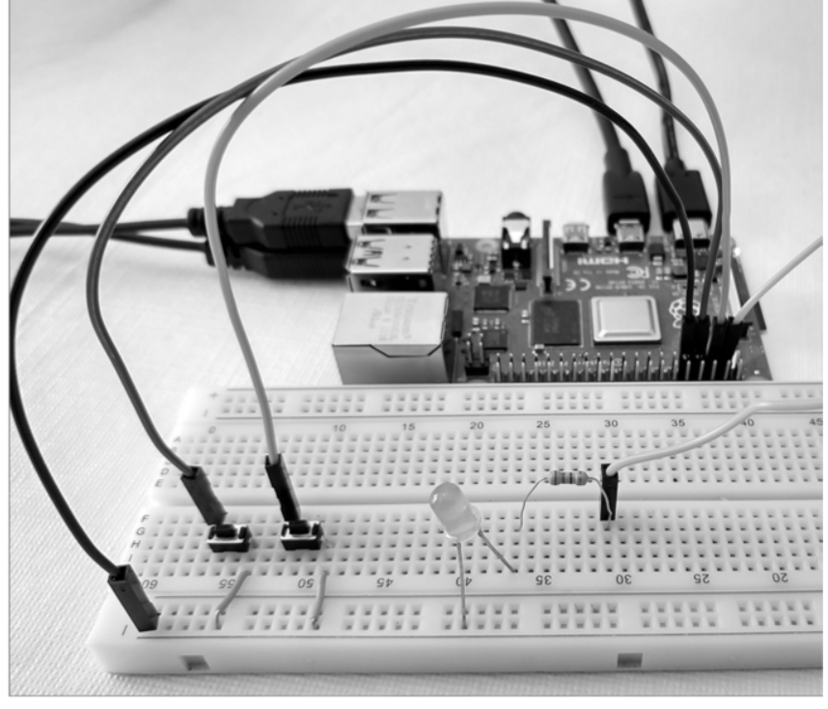 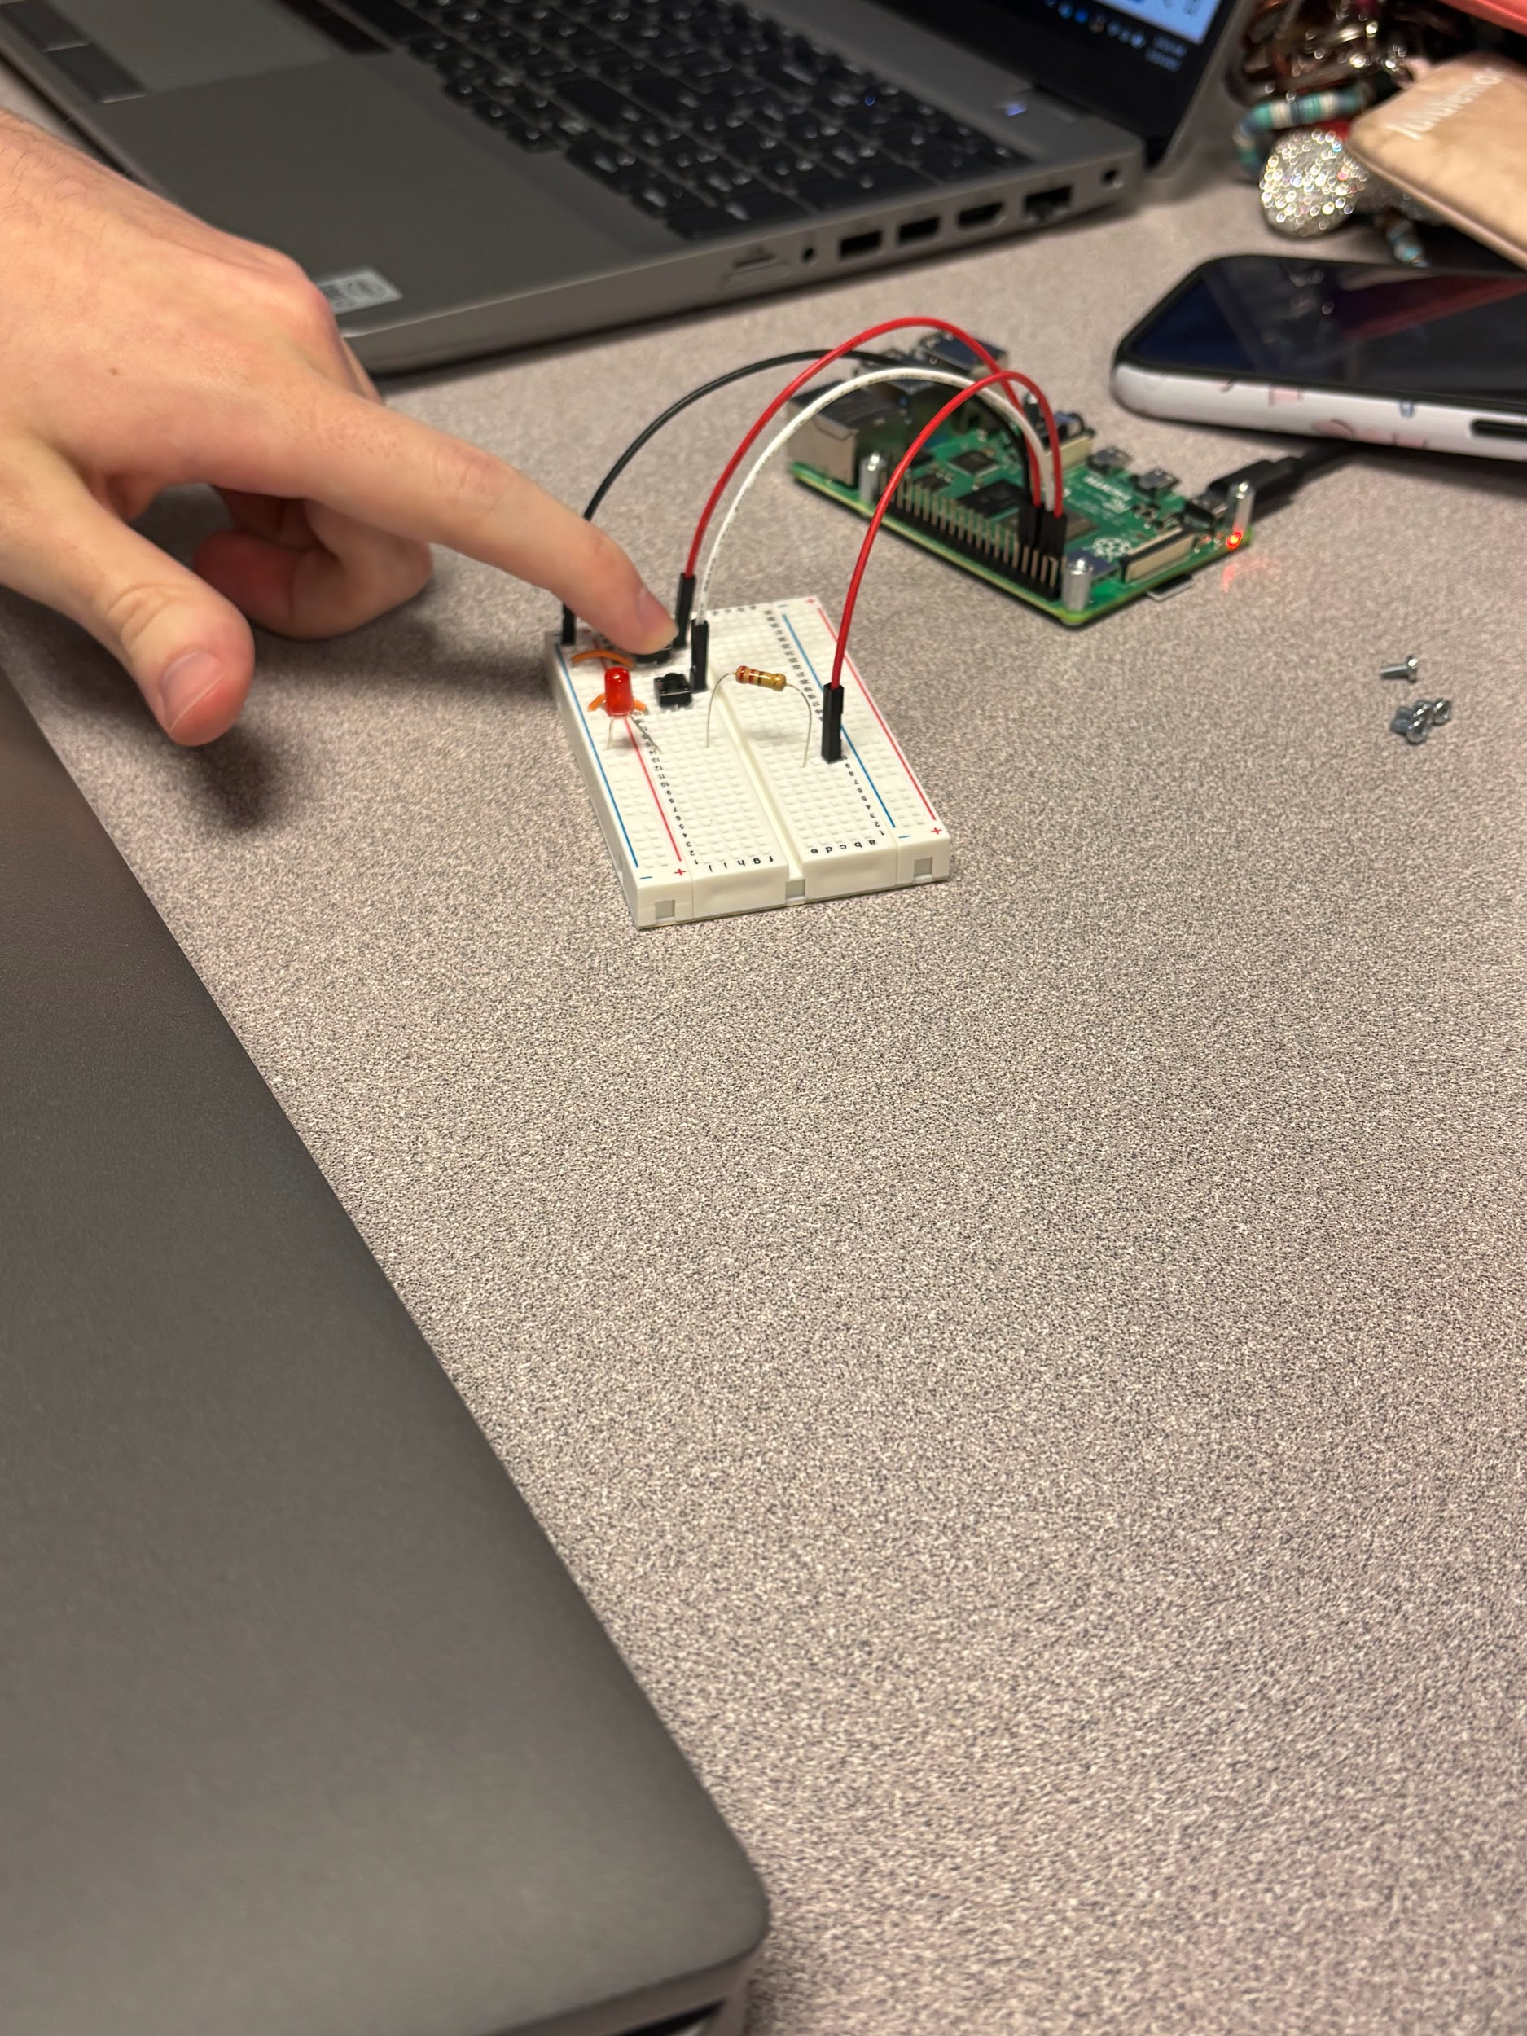

Then we put the code into the computer and start running it to turn.

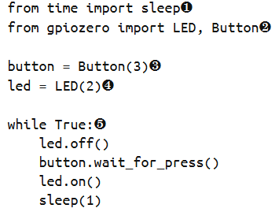

Then we did a vending machine program controlled by an SR latch, an AND gate, and a capacitor. Pressing the coin button increases the credit count by one, pressing the vend button simulates vending an item. If the credit count is greater than 0, the Vend LED briefly trunks on and the credit count decreases by one. If the credit count is 0, nothing happens when the VEND button is pressed. Every actionable button press, whether COIN or VEND, causes the program to print the current number of credits.

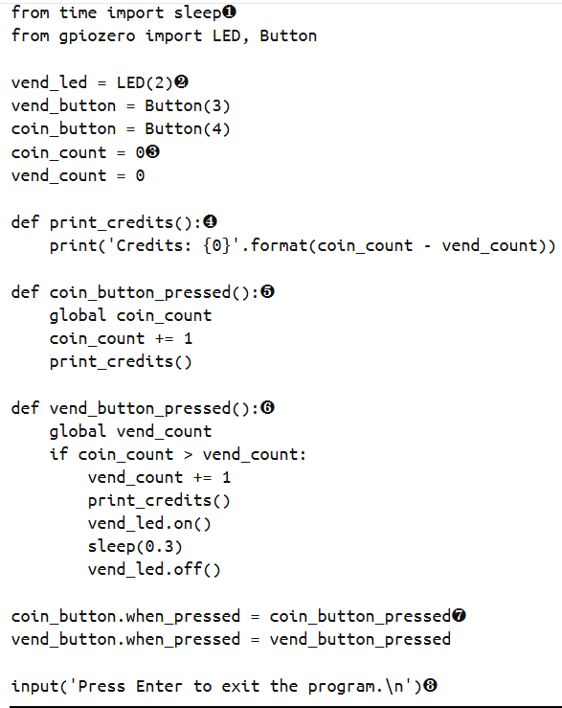

After the coding for the raspberry pi vending machine was successful we added a html code that was sent over the network.